assignment 4

1.Write a Java program to create a class called Employee with methods called work() and getSalary(). Create a subclass called HRManager that overrides the work() method and adds a new method called addEmployee().

CODE

class Employee {

private double salary;

public Employee(double salary) {

this.salary = salary;

}

public void work() {

System.out.println("Employee is working.");

}

public double getSalary() {

return salary;

}

}

class HRManager extends Employee {

public HRManager(double salary) {

super(salary);

}

@Override

public void work() {

System.out.println("HR Manager is managing human resources.");

}

public void addEmployee(String employeeName) {

System.out.println("Adding employee: " + employeeName);

}

}

public class Main {

public static void main(String[] args) {

Employee emp = new Employee(50000);

emp.work();

System.out.println("Employee Salary: $" + emp.getSalary());

HRManager hrManager = new HRManager(150000);

hrManager.work();

System.out.println("HR Manager Salary: $" + hrManager.getSalary());

hrManager.addEmployee("John Doe");

}

}



2.Write a Java program to create a vehicle class hierarchy. The base class should be Vehicle, with subclasses Truck, Car and Motorcycle. Each subclass should have properties such as make, model, year, and fuel type. Implement methods for calculating fuel efficiency, distance traveled, and maximum speed.

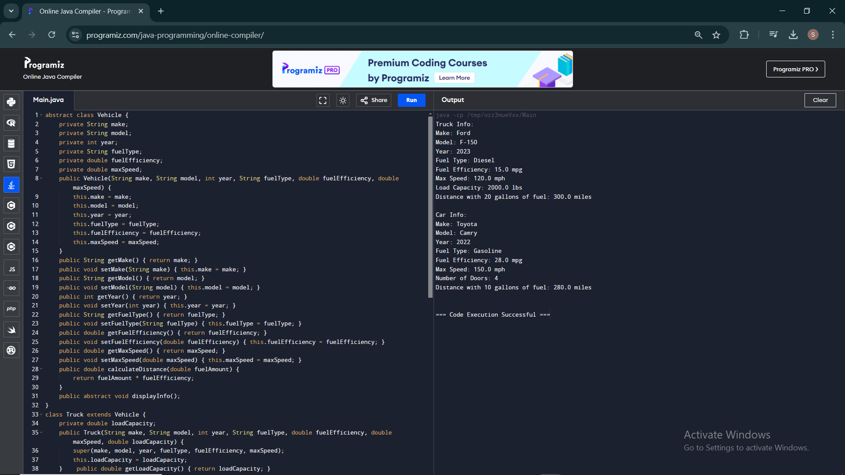

3.Write a Java program that creates a class hierarchy for employees of a company. The base class should be Employee, with subclasses Manager, Developer, and Programmer. Each subclass should have properties such as name, address, salary, and job title. Implement methods for calculating bonuses, generating performance reports, and managing projects.

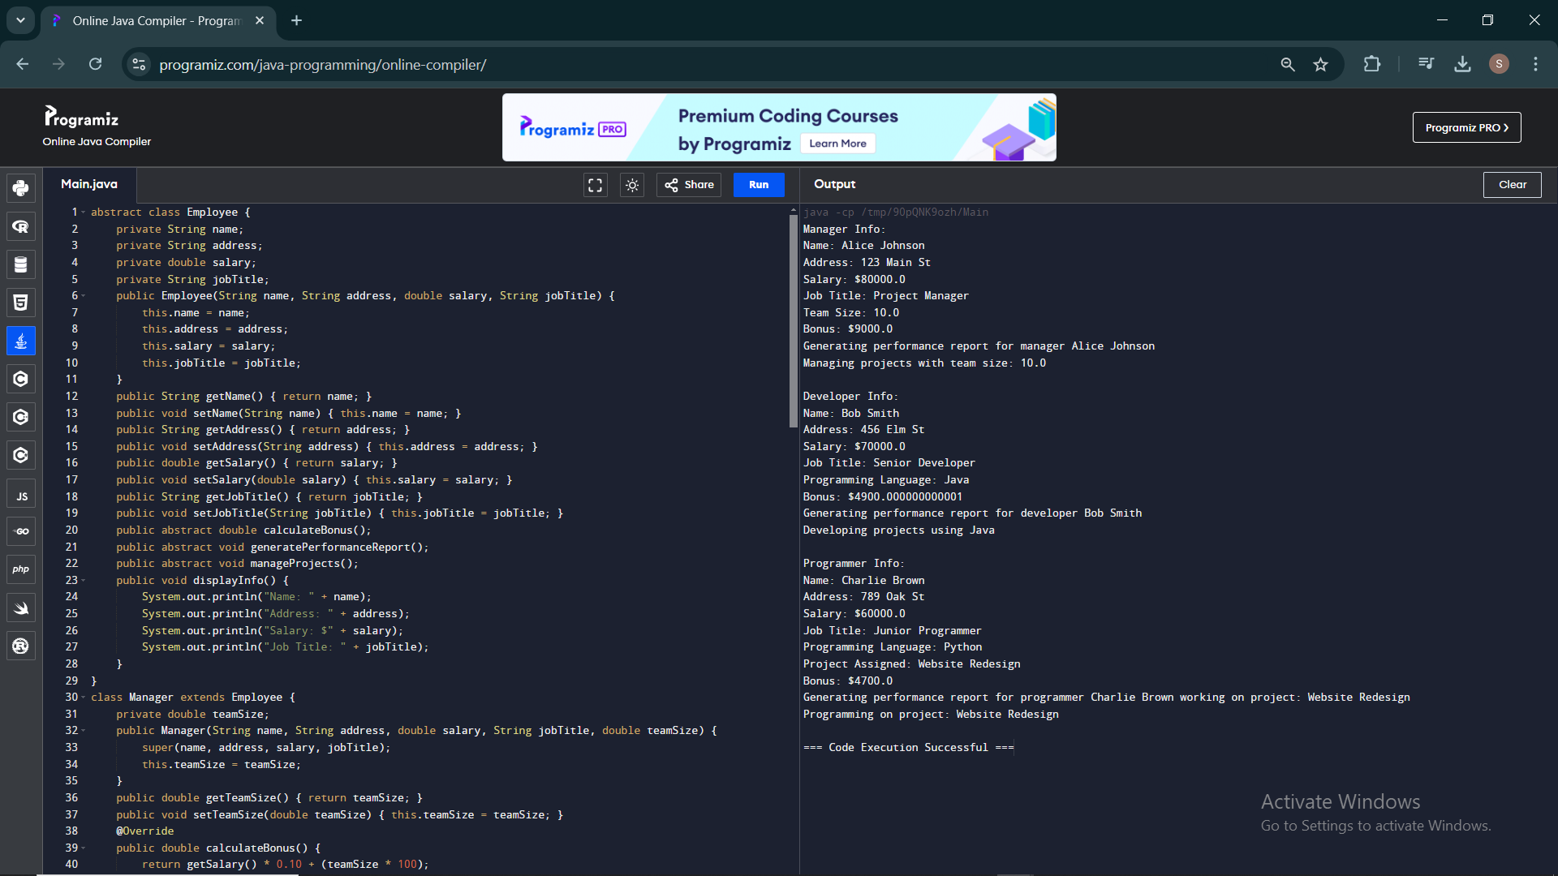

4.Write a Java program to create an abstract class Shape with abstract methods calculateArea() and calculatePerimeter(). Create subclasses Circle and Triangle that extend the Shape class and implement the respective methods to calculate the area and perimeter of each shape

CODE

abstract class Shape {

public abstract double calculateArea();

public abstract double calculatePerimeter();

}

class Circle extends Shape {

private double radius;

public Circle(double radius) {

this.radius = radius;

}

public double getRadius() { return radius; }

public void setRadius(double radius) { this.radius = radius; }

@Override

public double calculateArea() {

return Math.PI \* radius \* radius;

}

@Override

public double calculatePerimeter() {

return 2 \* Math.PI \* radius;

}

}

class Triangle extends Shape {

private double side1;

private double side2;

private double side3;

public Triangle(double side1, double side2, double side3) {

this.side1 = side1;

this.side2 = side2;

this.side3 = side3;

}

public double getSide1() { return side1; }

public void setSide1(double side1) { this.side1 = side1; }

public double getSide2() { return side2; }

public void setSide2(double side2) { this.side2 = side2; }

public double getSide3() { return side3; }

public void setSide3(double side3) { this.side3 = side3; }

@Override

public double calculateArea() {

double s = (side1 + side2 + side3) / 2;

return Math.sqrt(s \* (s - side1) \* (s - side2) \* (s - side3));

}

@Override

public double calculatePerimeter() {

return side1 + side2 + side3;

}

}

public class Main {

public static void main(String[] args) {

Circle circle = new Circle(5.0);

Triangle triangle = new Triangle(3.0, 4.0, 5.0);

System.out.println("Circle:");

System.out.println("Radius: " + circle.getRadius());

System.out.println("Area: " + circle.calculateArea());

System.out.println("Perimeter: " + circle.calculatePerimeter());

System.out.println();

System.out.println("Triangle:");

System.out.println("Sides: " + triangle.getSide1() + ", " + triangle.getSide2() + ", " + triangle.getSide3());

System.out.println("Area: " + triangle.calculateArea());

System.out.println("Perimeter: " + triangle.calculatePerimeter());

}

}

